Servo Reducer

Contact Information
Name: | Email:
Company: | Phone: |  | Fax:
Address: | State: | Zip:

Application:
Machine description
Type of Machine:

What is being driven:

Detail (# of teeth, pitch, module, Pitch Dia, width, etc.):

Output of Gearbox:
Keyed Shaft Smooth Shaft Flanged Hollow
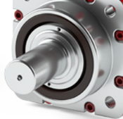
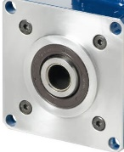
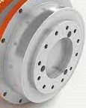
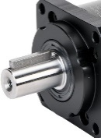
□ □ □ □

Input Design (Transmission):
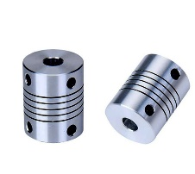
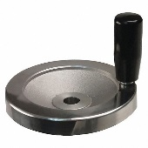
☐ Coupling ☐ Pulley ☐ Gear ☐ Other
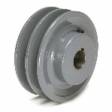
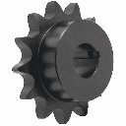

Choose Application Type: Mounting Position:
☐ Rotary Axis ☐ Horizontal Shaft
☐ Linear Axis ☐ Vertical Shaft

Specification Value Units
Max. Output Speed: |  | RPM
Max. Output Torque:
Max. Acceleration Rate: |  | Rads/s^2
Acceleration Time: |  | S
Constant Speed Time: |  | S
Deceleration Time: |  | S
Dwell Time: |  | S
Output Inertia:
Coefficient of Friction: |  | μ
Constant External Torque:
Axis Accuracy:
Environment/ Temp. |  | IP / F °
Cycle/ Lifetime:

Reducer Definition:
Configuration: Angular Backlash (arc-min.):
☐ In Line Low: __________
☐ Right Angle Standard: __________
Type:
☐ Planetary ☐ Servo Worm ☐ Bevel
Ratio: ______________

Motor Information
Motor Manufacture: |  | Model Number:
Rated Input Speed: |  |  | RPM
Max. Input Speed: |  |  | RPM
Rated Torque |  |  | ☐ Nm ☐ Lb.in
Max. Torque |  |  | ☐ Nm ☐ Lb.in
Rotor Inertia |  |  | ☐J reflected load ☐ J motor

Comments:

